VPI Data Warehouse

This document contains information on the collection and hopefully the creation of the VPI Data Warehouse.

### Resources

The following information is a list of resources used in the research of the warehouse.

<http://oirap.rutgers.edu/dwbasics.pdf>

<http://www.dwbiconcepts.com/data-warehousing/18-dwbi-basic-concepts.html>

<http://www.kimballgroup.com/>

<http://www.kimballgroup.com/data-warehouse-business-intelligence-resources/>

The Kimball Lifecycle:

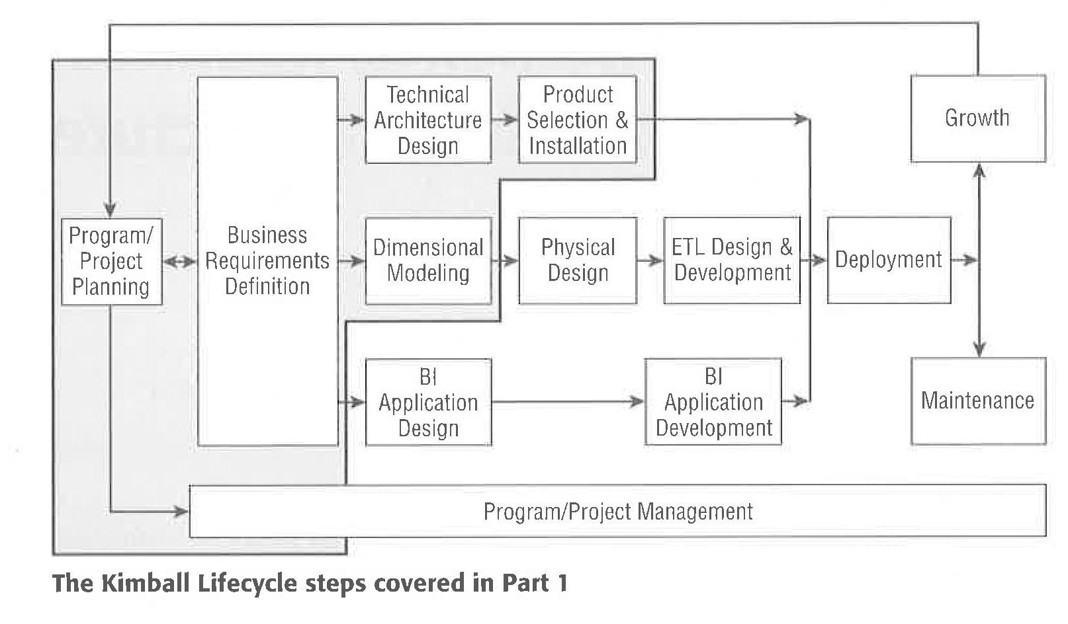

The first step is to gather requirements.

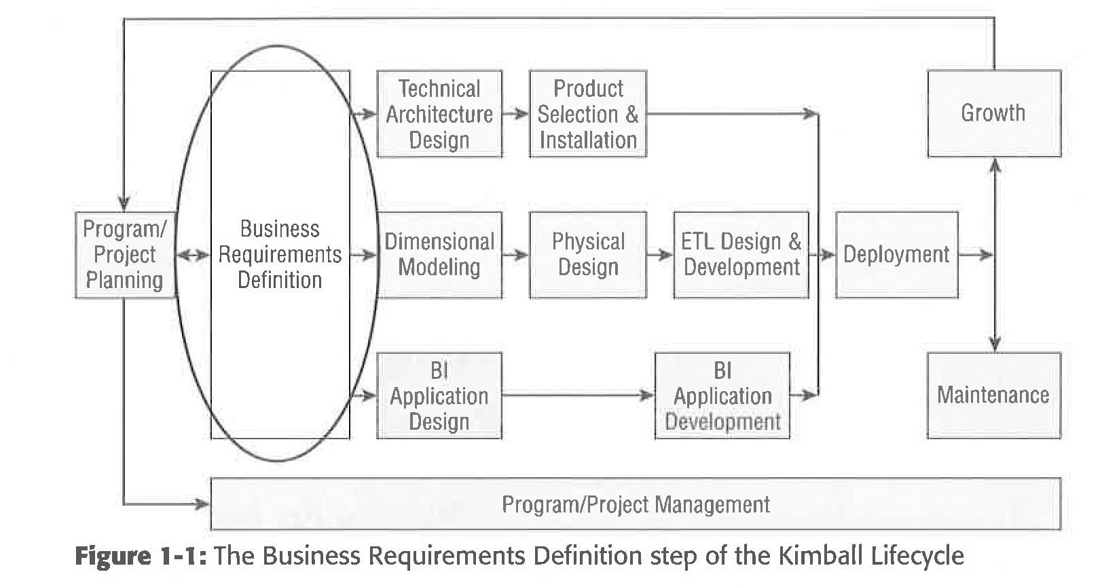

* Get a sponsor.
* Define Enterprise-level biz requirements.
* Program requirements.
* Prioritizing the biz requirements.

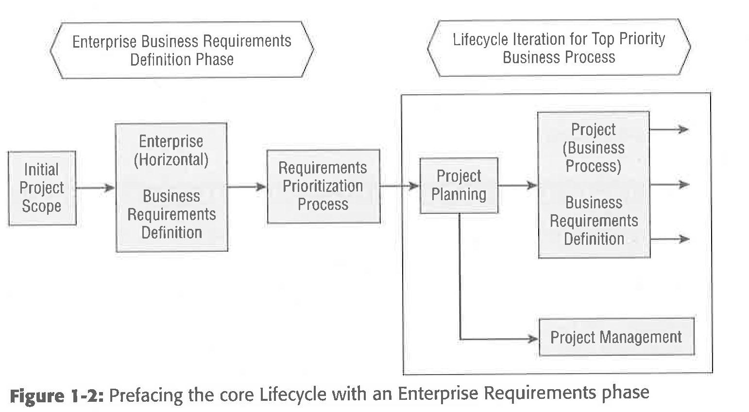

Conduct an Enterprise level phase to get a broad enterprise perspective. One of the long-term goals is to build an enterprise information infrastructure.

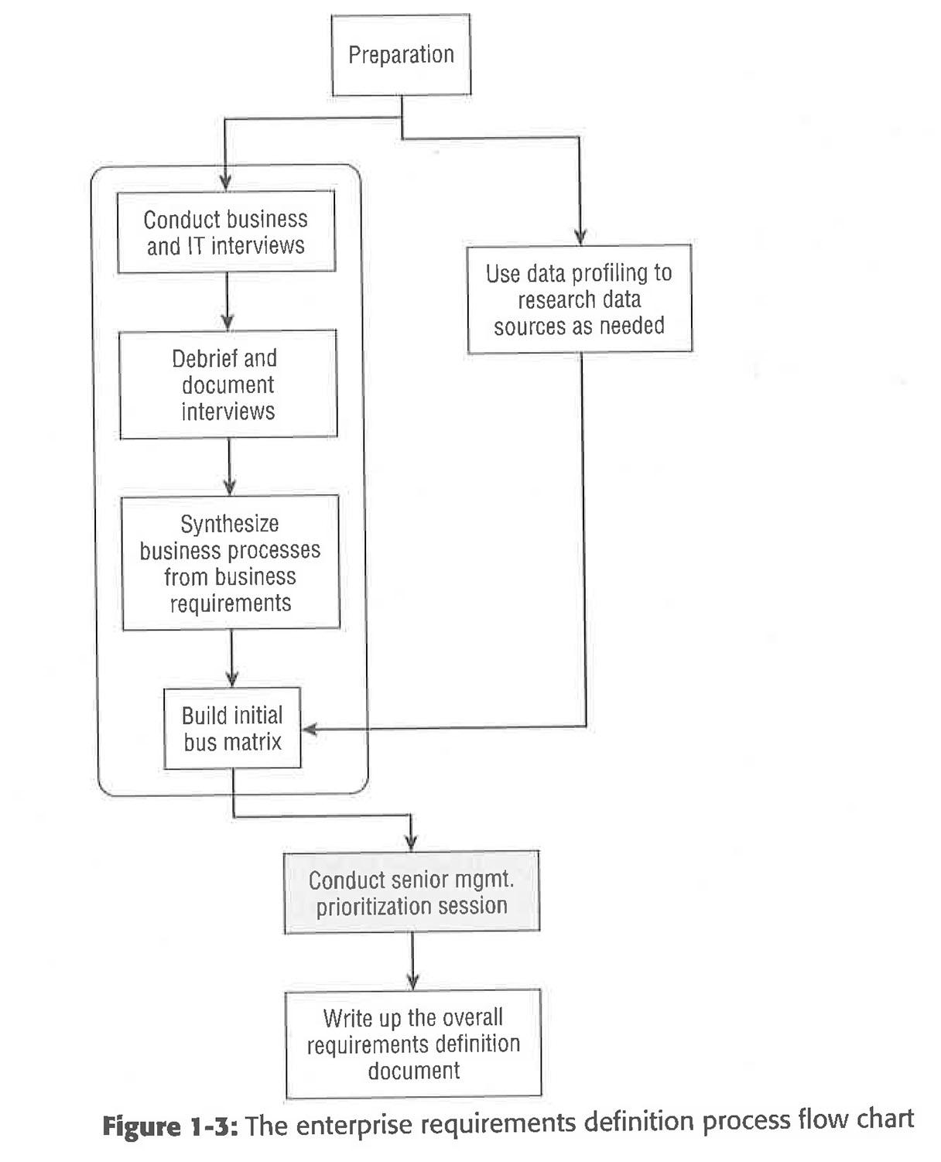

The results that follow use the fictitious company Adventureworks as the subject of the topics that are covered. Any references to persons living or dead would be weird.

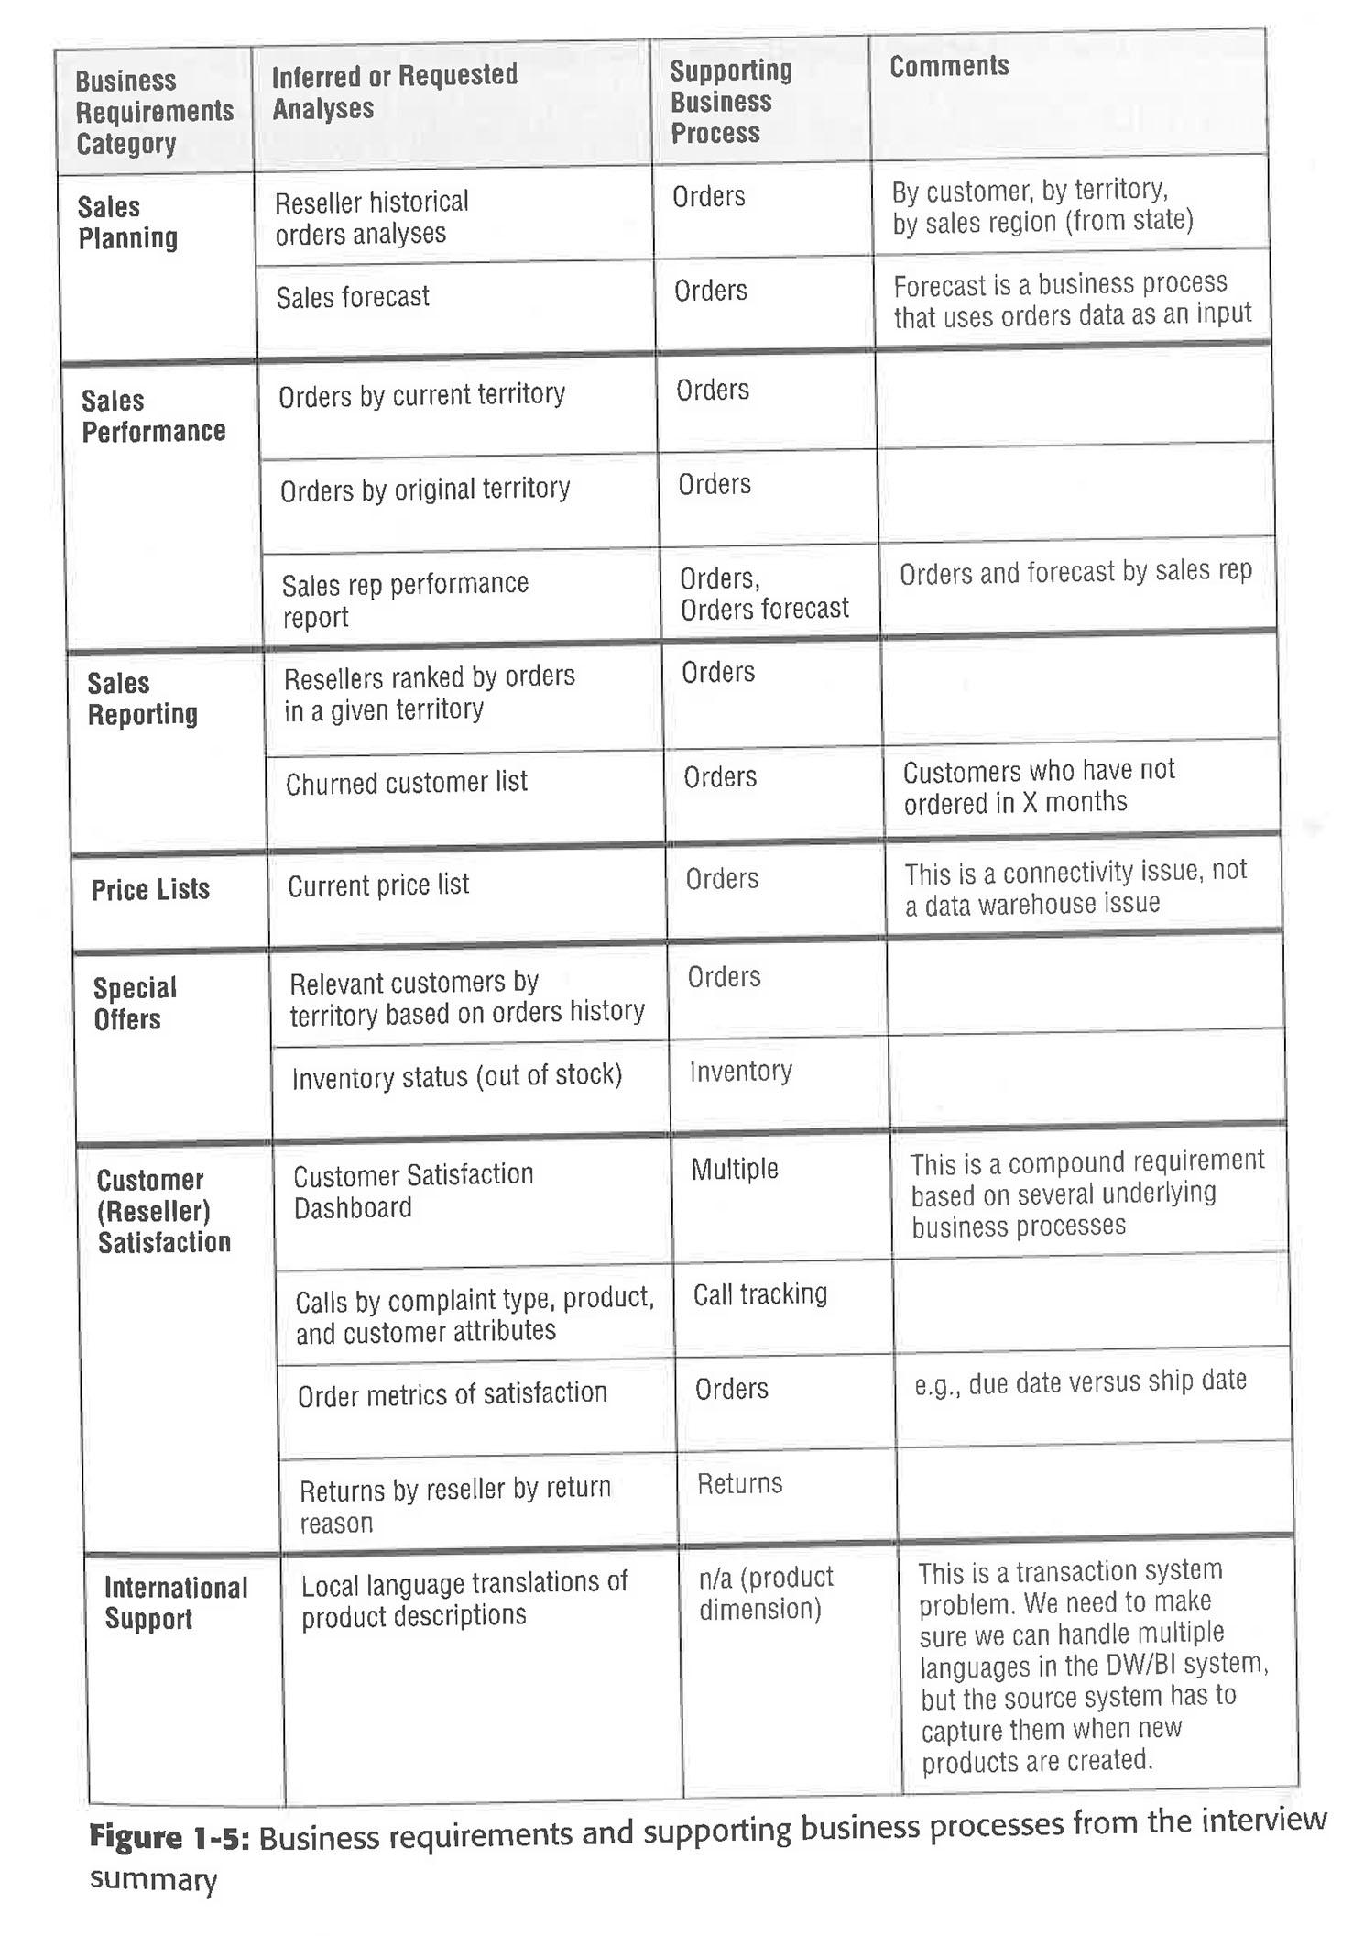

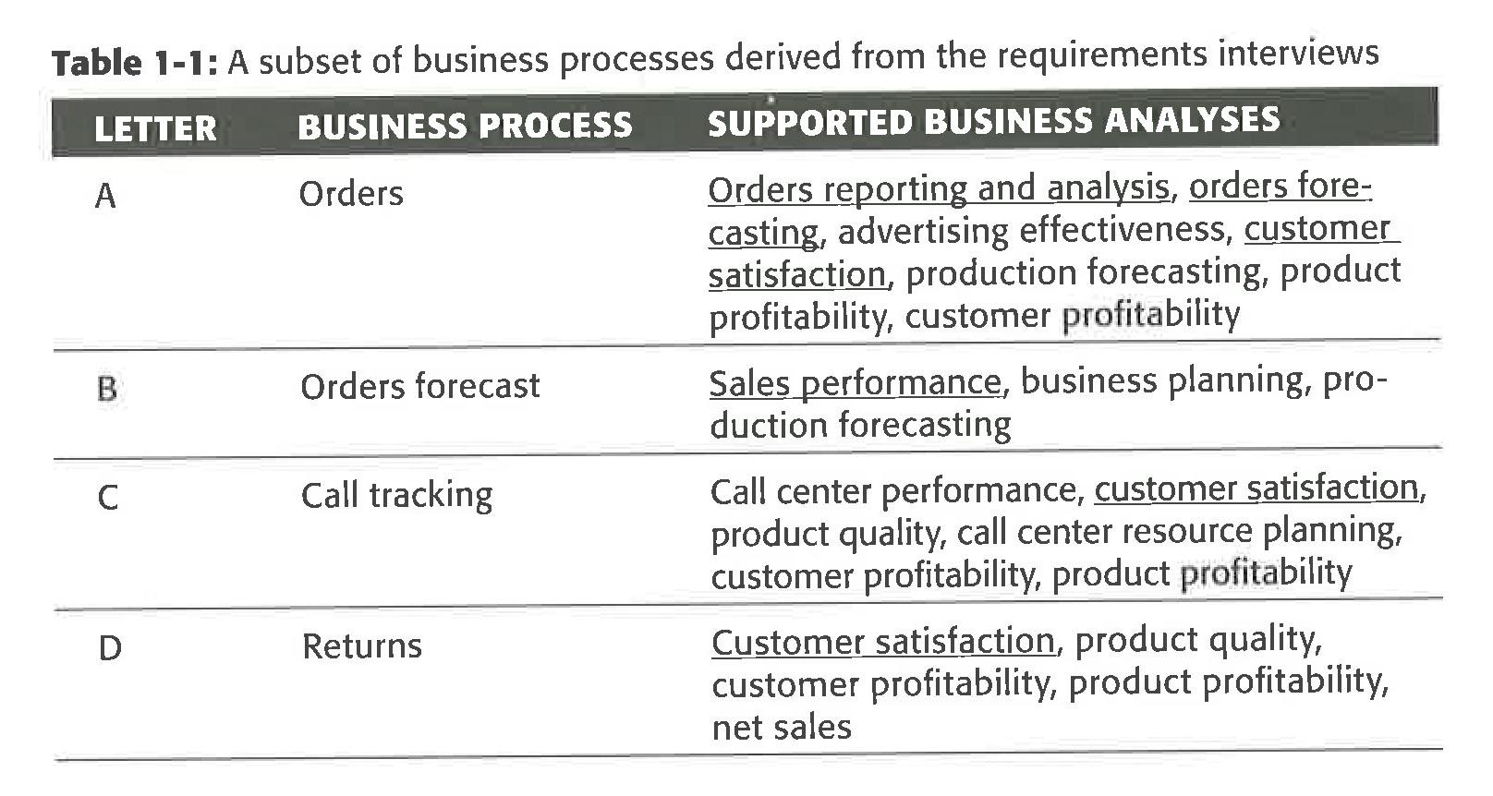

The Letter column is used as a shorthand reference for later use in other material.

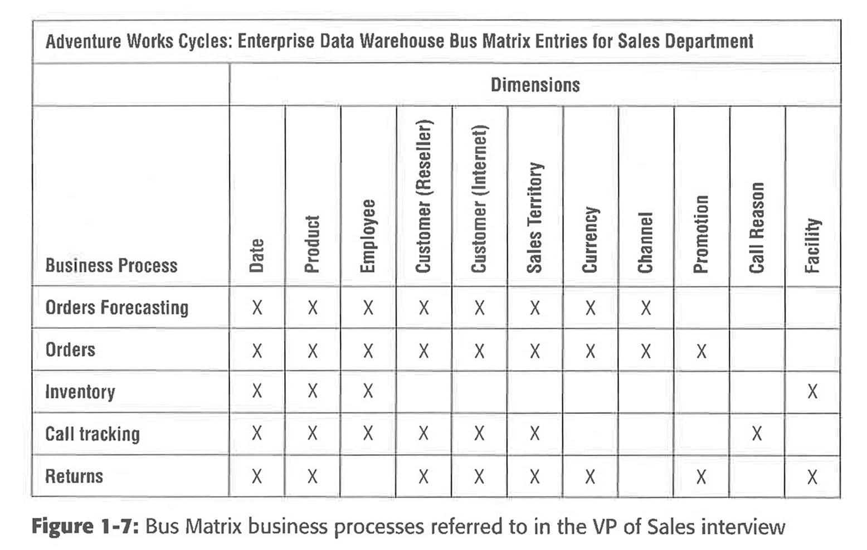

After all of the interviews and studying the results your list should have those business processes that would have impact for the company.

Now comes the part of prioritization of those processes.

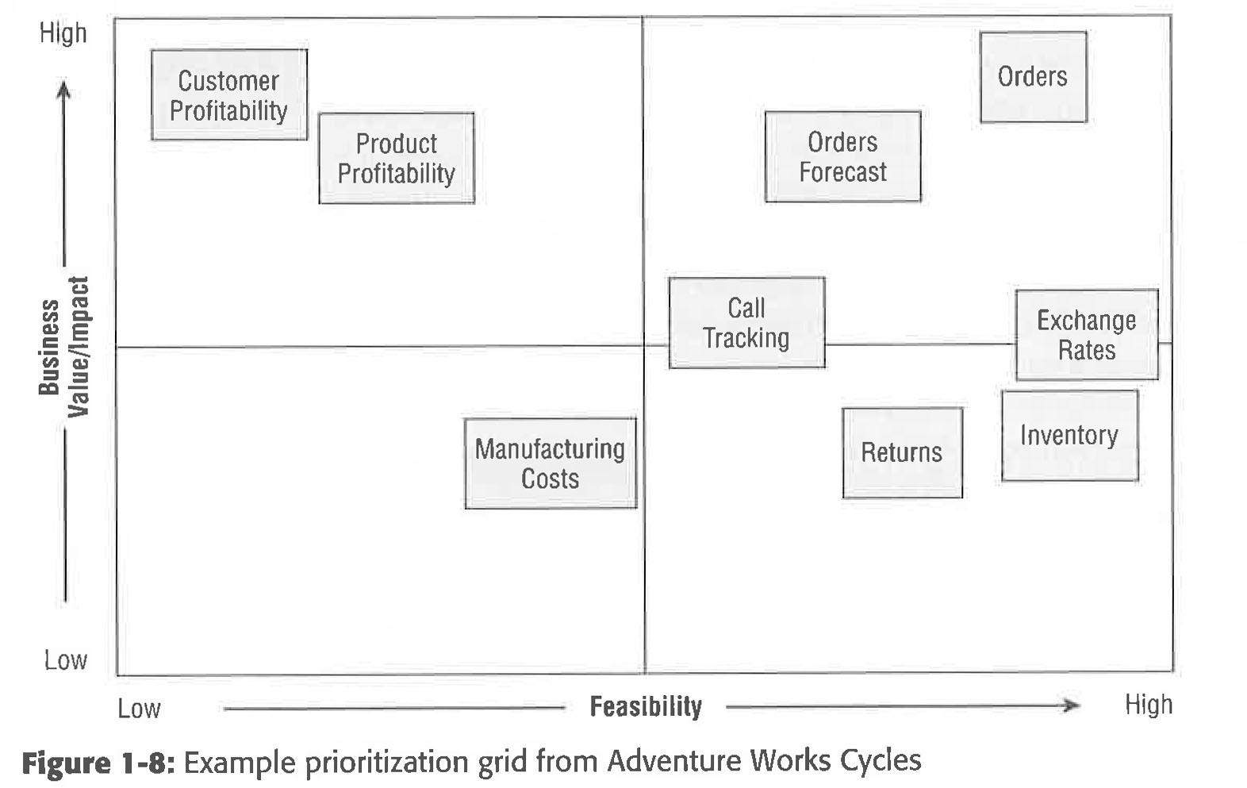

You can conduct a session with the group to come up with the above grid. You can then finalize the overall requirements document by including the resulting list of prioritized business processes.

Now gather the project-level requirements by following the same basic process as the enterprise requirements gathering process. Preparation, interviews, and documentation on the selected process. You are drilling down in each process this is going help in the analyses, data models, and technologies required to make it work. You will more specific about the kinds of new reports and analyses people want to see as input to the BI application track.